WPL LAB 3 HOME ASSIGNMENT
name: Abhinav Singh Bhagtana
section: A
roll no: 29
reg no: 230905225

Q1.Design a webpage. The page contains:
a. Dropdown list with HP, Nokia, Samsung, Motorola, Apple as items.
b. Checkbox with Mobile and Laptop as items.
Textbox where you enter
quantity.
c. There is a button with text as ‘Produce Bill’.

<!DOCTYPE html>
<html lang="en">
<head>
<meta charset="UTF-8">
<title>Bill Generator</title>
<script src="https://code.jquery.com/jquery-3.7.1.min.js"></script>
<style>
body { font-family: 'Segoe UI', Tahoma, Geneva, Verdana, sans-serif; display: flex; justify-content: center; padding-top: 50px; background-color: #f4f4f9; }
.bill-card { background: white; padding: 30px; border-radius: 12px; box-shadow: 0 4px 15px rgba(0,0,0,0.1); width: 350px; }
h2 { text-align: center; color: #333; margin-top: 0; }
.section { margin-bottom: 20px; }
label { display: block; font-weight: bold; margin-bottom: 8px; color: #555; }
select, input[type="number"] { width: 100%; padding: 10px; border: 1px solid #ddd; border-radius: 6px; box-sizing: border-box; }
.checkbox-group { display: flex; gap: 15px; align-items: center; }
button { width: 100%; padding: 12px; background-color: #007bff; color: white; border: none; border-radius: 6px; font-size: 16px; cursor: pointer; transition: background 0.3s; }
button:hover { background-color: #0056b3; }
</style>
</head>
<body>

<div class="bill-card">
<h2>Generate Bill</h2>

<div class="section">
<label>Select Brand:</label>
<select id="brand">
<option value="50000">HP (₹50,000)</option>
<option value="15000">Nokia (₹15,000)</option>
<option value="25000">Samsung (₹25,000)</option>
<option value="12000">Motorola (₹12,000)</option>
<option value="80000">Apple (₹80,000)</option>
</select>
</div>

<div class="section">
<label>Accessories / Category:</label>
<div class="checkbox-group">
<span><input type="checkbox" class="cat" value="500"> Mobile</span>
<span><input type="checkbox" class="cat" value="2000"> Laptop</span>
</div>
</div>

<div class="section">
<label>Quantity:</label>
<input type="number" id="qty" placeholder="Enter quantity" min="1" value="1">
</div>

<button id="btnBill">Produce Bill</button>
</div>

<script>
$(document).ready(function() {
$("#btnBill").click(function() {
// 1. Get Brand Price
let brandPrice = parseInt($("#brand").val());

// 2. Add Checkbox values
let extraCharge = 0;
$(".cat:checked").each(function() {
extraCharge += parseInt($(this).val());
});

// 3. Get Quantity
let quantity = parseInt($("#qty").val());

// Validation check
if (!quantity || quantity <= 0) {
alert("Please enter a valid quantity.");
return;
}

// 4. Calculation
let total = (brandPrice + extraCharge) * quantity;

// 5. Output via Alert
alert("--- INVOICE ---\n" +
"Base Price: " + brandPrice + "\n" +
"Extra Charges: " + extraCharge + "\n" +
"Quantity: " + quantity + "\n" +
"------------------------\n" +
"Total Amount: ₹" + total);
});
});
</script>

</body>
</html>

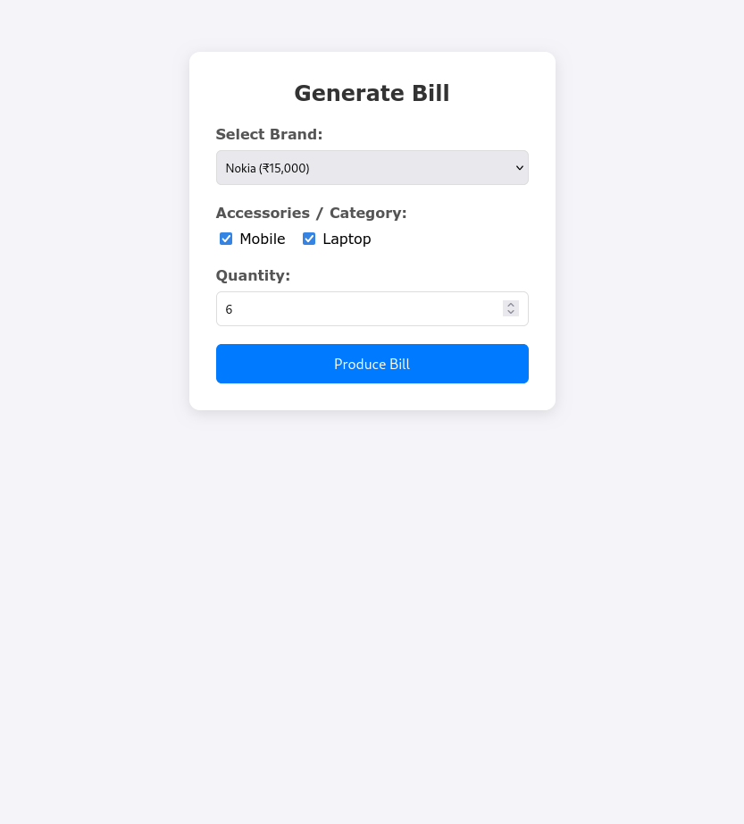

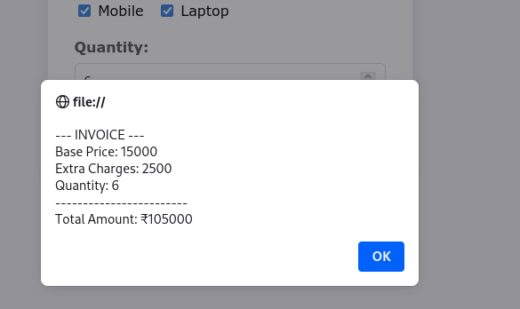
Q2.Implement the bouncing ball using animate() function.
<!DOCTYPE html>
<html>
<head>
<title>jQuery Bouncing Ball</title>
<script src="https://code.jquery.com/jquery-3.7.1.min.js"></script>
<style>
#stage {
width: 100%;
height: 400px;
background: #f0f0f0;
position: relative;
border-bottom: 5px solid #333;
overflow: hidden;
}
#ball {
width: 50px;
height: 50px;
background: #ff4757;
border-radius: 50%;
position: absolute;
left: 50%;
transform: translateX(-50%);
top: 0px;
}
</style>
</head>
<body>

<div id="stage">
<div id="ball"></div>
</div>

<button id="startBtn" style="margin-top: 20px; padding: 10px 20px;">Start Bouncing</button>

<script>
$(document).ready(function() {
function bounce() {
// Step 1: Move Down (to the floor)
$("#ball").animate({
top: "350px" // Stage height (400) minus Ball height (50)
}, 500, "swing", function() {
// Step 2: Move Up (back to top)
$("#ball").animate({
top: "0px"
}, 500, "swing", function() {
// Step 3: Repeat the function
bounce();
});
});
}

$("#startBtn").click(function() {
bounce();
$(this).attr("disabled", true).text("Bouncing...");
});
});
</script>

</body>
</html>
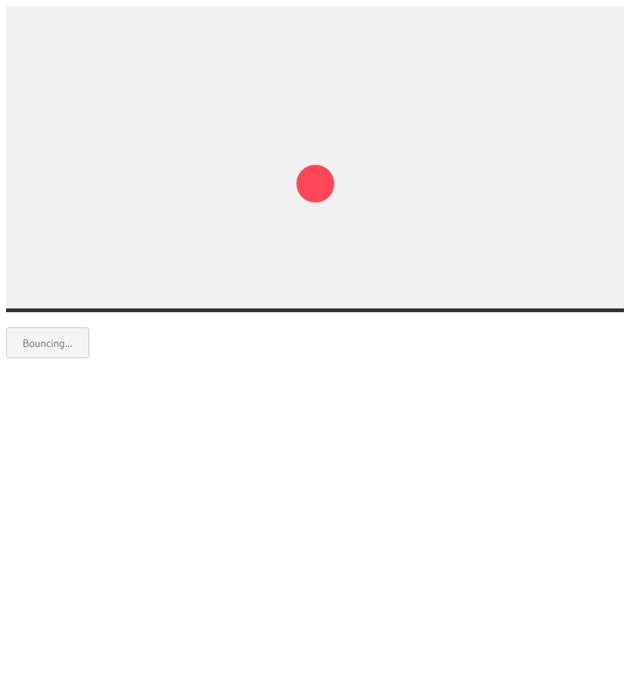
Q3.Write a web page which displays image and show the sliding text on the image.
<!DOCTYPE html>
<html lang="en">
<head>
<meta charset="UTF-8">
<meta name="viewport" content="width=device-width, initial-scale=1.0">
<title>Image with Sliding Text</title>
<script src="https://code.jquery.com/jquery-3.7.1.min.js"></script>
<style>
/* Basic page styling */
body {
display: flex;
justify-content: center;
align-items: center;
min-height: 100vh;
margin: 0;
background-color: #333;
font-family: sans-serif;
}

/* 1. The Container */
/* This is crucial. It defines the boundary for the image and text.
'position: relative' is needed so children with 'absolute' position
are positioned relative to *this* box, not the whole page. */
.image-container {
position: relative;
width: 800px;
height: 450px;
border: 5px solid white;
box-shadow: 0 10px 20px rgba(0,0,0,0.5);
/* Ensures text doesn't get seen when it slides outside the box */
overflow: hidden;
background-color: #000; /* Fallback color */
}

/* The Image itself */
.image-container img {
width: 100%;
height: 100%;
object-fit: cover; /* Ensures image fills box without stretching */
display: block;
opacity: 0.7; /* Dim the image slightly to make text pop */
}

/* 2. The Sliding Text Wrapper */
/* This sits on top of the image using absolute positioning */
#slider-text {
position: absolute;
top: 50%; /* Center vertically */
left: -100%; /* Start off-screen to the left */
transform: translateY(-50%); /* Perfect vertical centering adjustment */
/* Styling the text appearance */
color: white;
font-size: 32px;
font-weight: bold;
background-color: rgba(0, 0, 0, 0.6); /* Semi-transparent black background */
padding: 15px 30px;
white-space: nowrap; /* Keeps text on one line */
border-radius: 5px;
}
</style>
</head>
<body>

<div class="image-container">
<img src="https://picsum.photos/id/1018/800/450" alt="Scenic Background">
<div id="slider-text">Welcome to our beautiful website!</div>
</div>

<script>
$(document).ready(function() {
// Define the function that performs one slide cycle
function slideTheText() {
// 1. Get necessary elements and measurements
var $textElement = $("#slider-text");
var containerWidth = $(".image-container").width();
var textWidth = $textElement.outerWidth();

// 2. Reset position: Calculate starting point just off-screen left
var startPos = -textWidth;
// 3. Calculate ending position: Just off-screen right
var endPos = containerWidth;

// Place the text at the starting position instantly
$textElement.css("left", startPos);

// 4. Animate to the ending position
$textElement.animate({
left: endPos
},
6000, // Duration in milliseconds (6 seconds for a slow slide)
"linear", // Easing: "linear" makes speed constant, "swing" speeds up/slows down
function() {
// Animation Complete Callback: Run the function again to loop!
slideTheText();
});
}

// Start the loop for the first time
slideTheText();

});
</script>

</body>
</html>


